- Write a program to demonstrate Inheritance. Define a base class Vehicle having properties like type, color, speed, brand and methods Run() and Display(). The Run() method should display a message “I am running” and the type of the vehicle. The Display() method should display the various properties of the vehicle. Derive a class Car and initialized the derived attributes of base class Vehicle. Finally, in the Main() method execute Run() and Display()using an object of the derived class Car.

Solution:

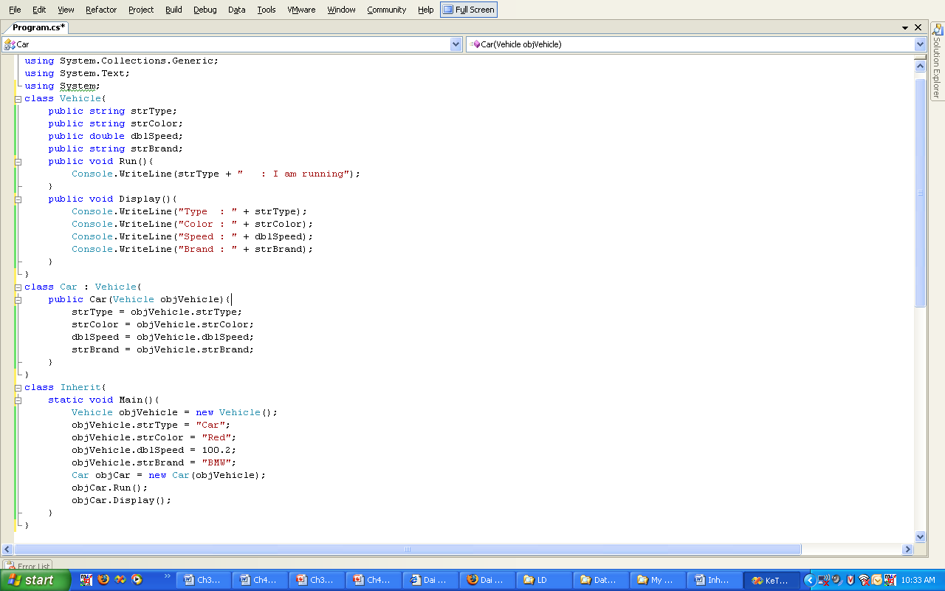
The output of the program is as shown in the Figure 2.4.

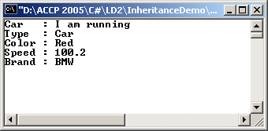

Figure 2.4: Output of Vehicle.cs

- Consider the previous question. Override the Run() method in the derived class to display a message “The CAR is running”.

Solution:
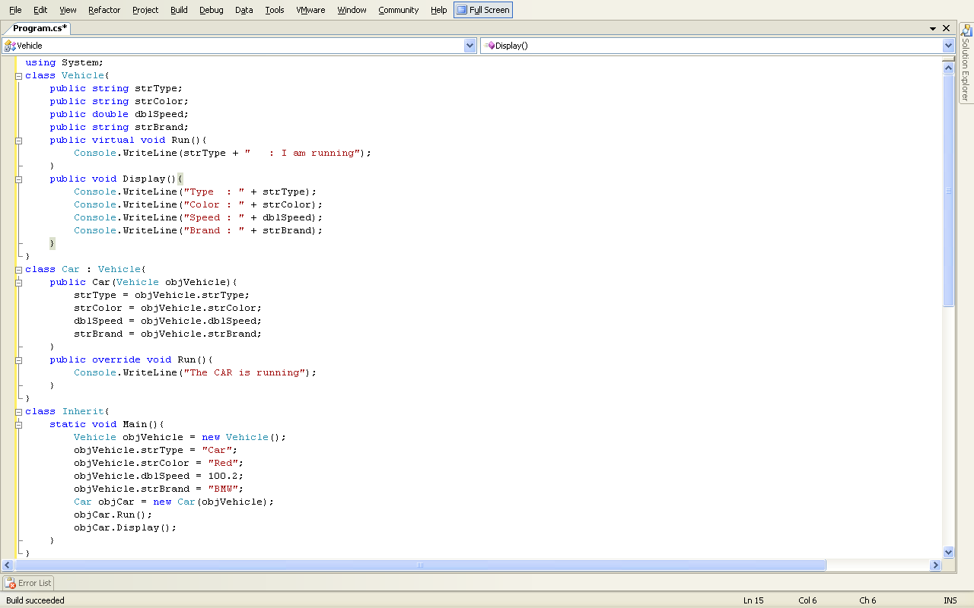
The output of the program is as shown in the Figure 2.5.

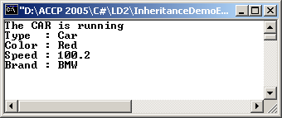

Figure 2.5: Output of Vehicle.cs

- Write a program to display the value of two integers using parameterized constructor and a method. Create two objects of this and pass the sets of values (10, 20) and (30, 40) respectively. Overload the ‘+’ operator to add the two x values and two y values of these objects to form a new object (x, y). The answer should be (10+30, 20+40) = (40, 60).

Solution:

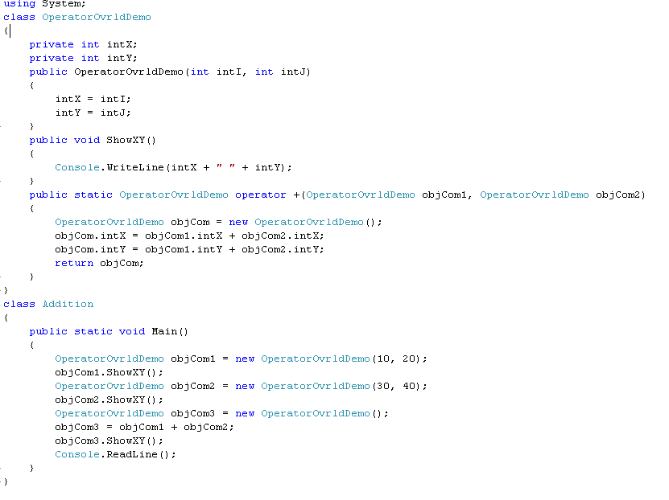
The output of the program is as shown in the Figure 2.6.

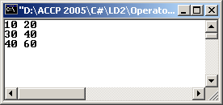

Figure 2.6: Output of OperatorOvrldDemo.cs

- Write a program to demonstrate the use of abstract class. Create two derived classes Blue and Green based on a generic Color class. Color class should define a template for a method Fill(string colorname). This method should be implemented by the classes Blue and Green. The Fill method should display a message “Fill me up with” and then the color name.

Solution:

using System;

abstract class Color
{
public abstract void Fill(string strColor);
}
class Blue : Color
{
public override void Fill(string strColor)
{
Console.WriteLine("Fill me up with " + strColor);
}
}
class Green : Color
{
public override void Fill(string strColor)
{
Console.WriteLine("Fill me up with " + strColor);
}
}

class ColorDemo
{
static void Main()
{
Blue b = new Blue();
b.Fill("Blue");

Green g = new Green();
g.Fill("Green");
}
}

The output of the above program is as shown in the Figure 3.1.

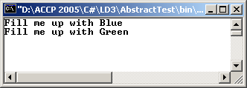

Figure 3.1: Output of Color.cs

- Write a program to demonstrate polymorphism and the use of keyword base. Declare a class AppWindow having a virtual method CreateWindow(), displaying message “Window: drawing Window at top, left” where top and left are integer variables initialized in the constructor. Derive a class ListBox from AppWindow and initialize three parameters in its constructor; top, left and a string variable listBoxContents. Override CreateWindow() with the message “Writing string to the listbox: listBoxContents” and also display the virtual method of the base class. Derive another class Button from AppWindow and override the virtual method CreateWindow() with the message “Drawing a button at top, left”.

Execute CreateWindow() method for all the three classes.

Solution:

using System;

public class AppWindow
{
//Protected members
protected int top;
protected int left;

// constructor takes two integers to fix location on the console

public AppWindow(int top, int left)
{
this.top = top;
this.left = left;
}
// simulates drawing the AppWindow
public virtual void CreateWindow()
{
Console.WriteLine("Window: drawing Window at {0}, {1}",
top, left);
}

}
// ListBox derives from AppWindow
public class ListBox : AppWindow
{
private string listBoxContents;

// constructor adds a parameter and also call base constructor

public ListBox( int top, int left, string contents):base(top, left)
{
listBoxContents = contents;
}

// Overriding CreateWindow
public override void CreateWindow()
{
base.CreateWindow(); // invoking base method
Console.WriteLine ("Writing string to the listbox: {0}", listBoxContents);
}

}
// Button derives from AppWindow
public class Button : AppWindow
{
public Button(int top, int left): base(top, left)
{
}

// Overriding CreateWindow
public override void CreateWindow( )
{
Console.WriteLine("Drawing a button at {0}, {1}\n", top, left);
}
}
public class Tester
{
public static void Main()
{
AppWindow win = new AppWindow(-110,-0);
win.CreateWindow( );
win = new ListBox(3,4,"This is a list box");
win.CreateWindow();
win = new Button(5,6);
win.CreateWindow();
}
}

The output of the program is as shown in the Figure 3.2.

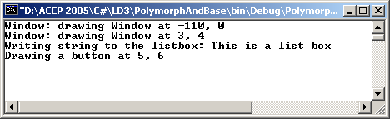

Figure 3.2: Output of AppWindow.cs

